Week 2 Internship Progress Report

Intern Name: Roonaq Imtiaz
Internal Supervisor: Sir Mukhtiar Zamin
Internship Organization: Allama Iqbal Open University (AIOU)
External Supervisor: Ms. Laiba Bukhari
Department: Directorate of ICT – Networks and Data Centre
Internship Domain: Cybersecurity
Week: Week 2 (20 Jan – 26 Jan 2026)

1. Objectives for Week 2
The objective of Week 2 was to gain an in-depth understanding of the Cyber Kill Chain framework, apply cybersecurity concepts to real-world attack scenarios, and develop presentation skills. This week also focused on strengthening network security knowledge through structured learning.

2. Planned Activities
- Study and research the Cyber Kill Chain framework
- Prepare and deliver a presentation on Cyber Kill Chain
- Continue learning through Coursera and TryHackMe
- Explore SOC-related concepts and defensive frameworks
- Maintain daily progress updates

3. Work Completed / Progress Achieved
During Week 2, the following tasks were completed:
- Studied all seven stages of the Cyber Kill Chain and their defensive significance.
- Conducted research using Google, YouTube, and TryHackMe to understand real-world cyber-attacks.
- Successfully delivered a Cyber Kill Chain presentation via Google Meet.
- Completed TryHackMe learning related to SOC Level 1, Cyber Defence Frameworks, and Cyber Kill Chain.
- Continued Coursera learning by completing modules from the Google Cybersecurity Certificate, including “Connect and Protect: Networks and Network Security.”

4. Learning Outcomes
By the end of Week 2, I developed a strong understanding of how cyber attacks progress through different stages and how early detection can reduce impact. I also improved my confidence in explaining cybersecurity concepts.

5. Certificates as proof

Coursera:
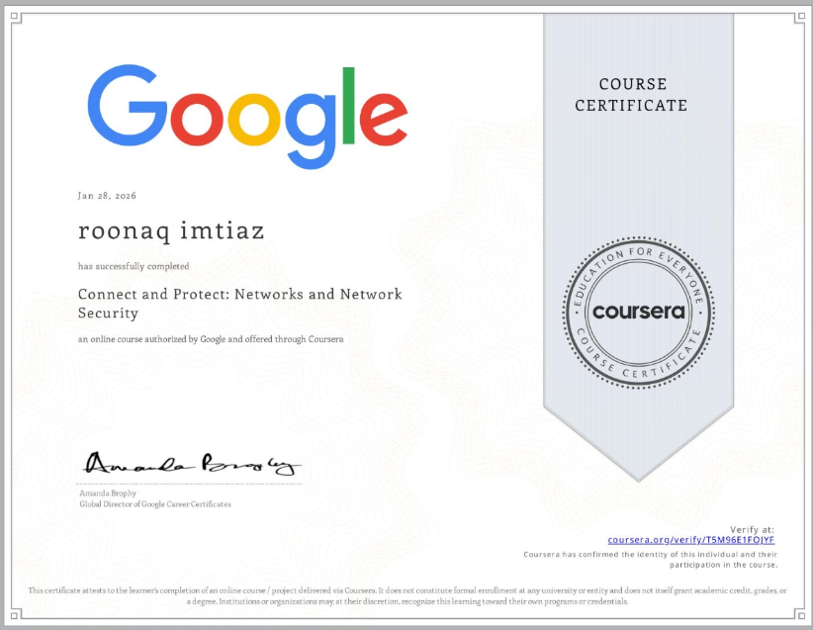
https://coursera.org/share/5603db6945ffd7bc4411a22250d0efa9

TryHackMe:
